IQSTAR Demo Check-list

IQSTAR setup:

IQTAR Bench Control can support multiple configurations through a flexible and customizable setup editor.

please select your architecture:

VNA based Setup (Setup n°1)

This setup supports :
- S-parameter Measurements (Forward Only and Full 2 Port)
- 1-Tone Power and Frequency sweeps
- 2-Tone measurements (Frequency Offset Option on the VNA required)
- VBW analysis (Frequency Offset Option on the VNA required)
- Data Visualization

Connectorized
On-Wafer

1-Tone Measurements (includes S-parameters Measurements)
CW Measurements Pulsed Measurements

2-Tone Measurements & VBW analysis

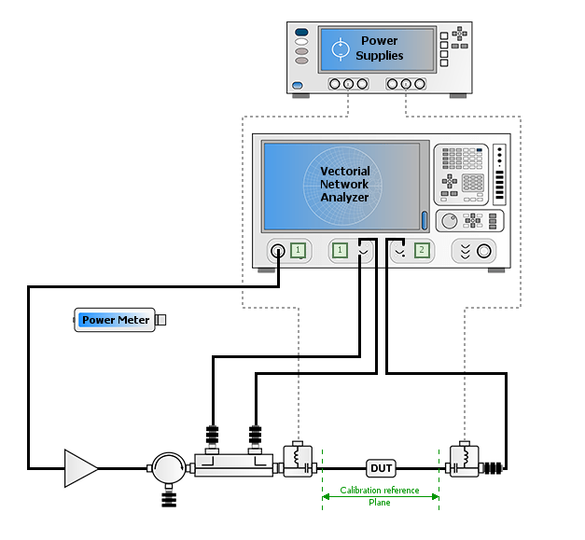

The illustration may not describe exactly the bench

Scalar Bench (Setup n°2)

This setup supports :
- 1-Tone Power and Frequency sweeps
- 2-Tone measurements using one (1) VSG or two (2) Signal Generators as sources.
- VBW analysis using one (1) VSG or two (2) Signal Generators as sources.
- Modulated Signal using VSG and VSA
- IQ Measurements using VSG and Spectrum
- Data Visualization

1-Tone Measurements
CW Measurement Pulsed Measurement

2-Tone Measurements & VBW Analysis
Modulated signal
IQ signal Measurements

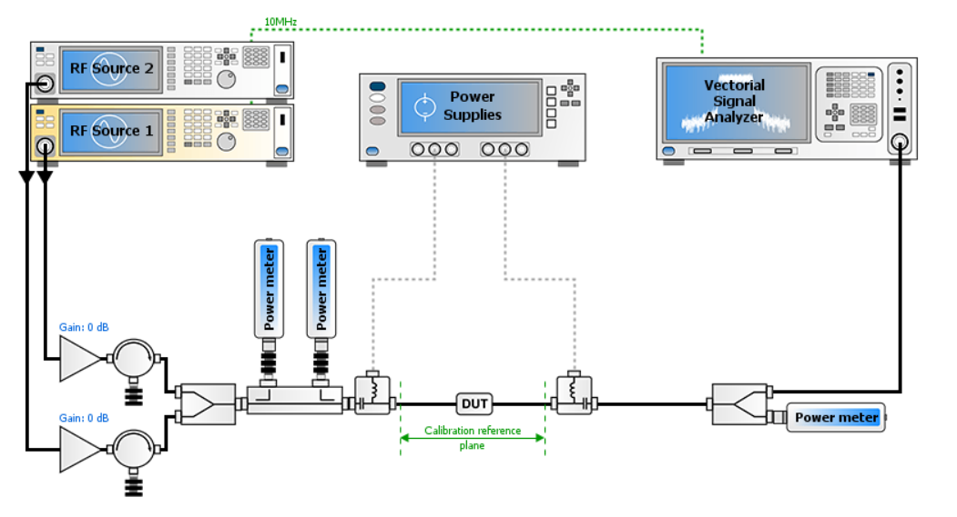

The illustration may not describe exactly the bench

Full Bnnch(Setup n°3)

This setup supports :
- S-parameter Measurements (Forward Only and Full 2 Port)
- 1-Tone Power and Frequency sweeps (in vector or Scalar mode)
- 2-Tone measurements using a VSG or 2 Signal Generators as sources (in vector or scalar mode).
- VBW analysis using a VSG or 2 Signal Generators as sources (in vector or scalar mode).
- Modulated Signal using VSG and VSA
- IQ Measurements using VSG and Spectrum
- Data Visualization

Connectorized
On-Wafer

1-Tone Measurements
CW Measurement Pulsed Measurement

2-Tone Measurements & VBW Analysis

Modulated signal

IQ signal measurements

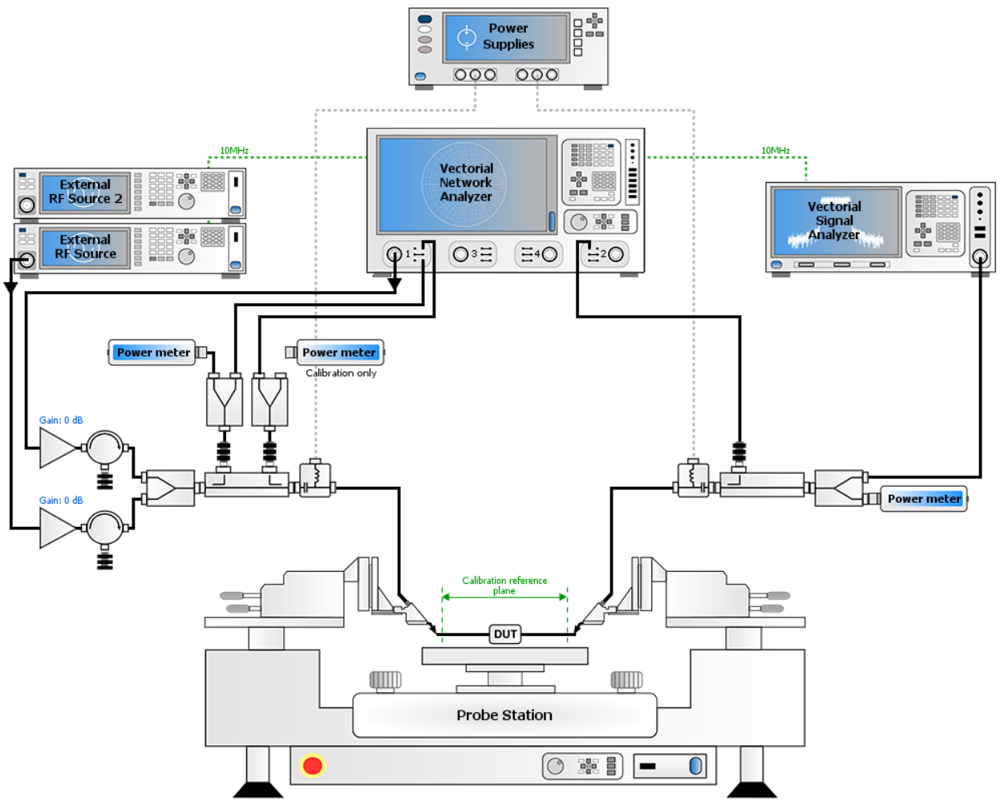

The illustration may not describe exactly the bench

The demo will be supported with the hardware listed hereafter. The hardware listing (option included) is a key point for the demo.

Seq | Nb unit(s) | Equipment | Manufacturer | Model | To be provided by | Comments
0 | 1 | USB-GPIB Interface |  |  |  | GPIB or LAN ?
1 | 1 | Vector Network Analyzer |  |  |  | Model ? Option ?  Frequency Offset ?
2 | 1 | Signal Generator |  |  |  | Pulse ? 2-Tones ? Modulated Signal ?
3 | 1 | DC power supply
4 | 1 | IV measurement unit
5 | 1, 2 or 3 | Power Meter |  |  |  | Pulsed ?
6 | 1 | Vector Signal Analyzer
7 | 1 or 2 or3 | Power combiner 1:2
8 | 2 | couplers
9 | 2 | Bias Tee
10 | 1 or 2 | Power Amplifiers
11 | 1 | Isolators
12 | 1 | 50Ω Load
13 | 1 | DUT & Test Fixture
14 | TBD | RF attenuators for VNA receivers
15 | TBD | RF cables, adaptors etc…
16 | 1 | Calibration KIT
17 | TBD | RF adpators
18 | 1 | Probe Station model and SW control

Table 1 : Hardware to be provided

Type of Device to be Characterized :

Provide a short device description
Transistor | BJT | HBT | LDMOS | MESFET | HEMT/PHEMT | MOSFET
Device Format | Wafer | Chip * | Packaged *
Data Sheet Available? | No |  | Yes |  | Yes, specify Web site  →
* Additional Information about the Device format:

Data & Test condition Requirements:

Output power
Power Gain
Frequency
DC power (Vout, Iout, Mean power dissipation) Approx. ..W average

Additional Comments/Requirements:

